FOR IMMEDIATE RELEASE
Contact:
Sharon D. Sheltzer
Sdsheltzer.arch@gmail.com | sharondsheltzer.com | (559)799-0996
Los Osos, CA

Author Sharon D. Sheltzer’s Lady of the Waves: Love in the Time of Climate Change signals a turning point in climate fiction, from dystopia to hope.
Book to be published June 9, 2026, by 12 Willows Press
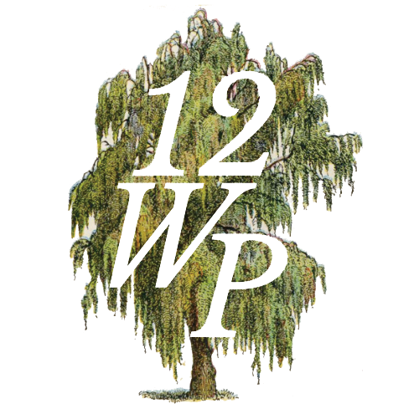
At a time when many climate stories focus on dystopian futures, Lady of the Waves takes a different path—offering readers an inspiring and emotionally engaging story that highlights courage, resilience, and personal growth. The novel explores how young people can confront environmental challenges, and be the solution instead of the victim.
“Many climate novels bring us into a catastrophic future, but studies show these stories immobilize readers. They think, ‘It’s so bad I give up,’” Sheltzer said.
In Lady of the Waves, A tsunami takes her family. A split second takes his best friend. From opposite sides of the globe a Finnish girl and a boy from San Francisco find each other and turn tragedy into action against the climate crisis.
The novel is expected to appeal to fans of young adult fiction, adults, educators, climate-aware readers, and book clubs interested in stories that combine compelling storytelling with timely issues.
Lady of the Waves will be available through major booksellers and online retailers beginning June 9, 2026. Advance review copies and interview opportunities are available upon request.
About the Author
Sharon D. Sheltzer writes fiction that explores environmental themes and the power of the next generation to shape the future. Ms. Sheltzer dedicated her architectural career to environmental awareness. The second book in this series is OperationFooledU, to be published soon.
For more information, review copies, or interview requests, please contact:
sdsheltzer.arch@gmail.com
sharondsheltzer.com

